План-конспект внеурочного учебного занятия в основной школе
Уровень обучающихся: 6 класс
Название работы: «Дети Блокады. Цена Победы.»

Пояснительная записка

В истории Великой Отечественной войны особое место занимает Блокада Ленинграда, которая продолжалась долгие 872 дня и была полностью снята только 27 января 1944 года в ходе Ленинградско‑Новгородской операции.

В честь этого события впервые за всю войну был дан салют не в Москве, а в самом Ленинграде. Тысячи жителей вышли на улицы, чтобы увидеть салют и порадоваться столь желанной победе у стен своего родного города. 27 января стало Днём воинской славы России.

Битва за Ленинград стала самой продолжительной в годы Великой Отечественной войны. Она длилась с 10 июля 1941 года по 9 августа 1944 года, когда финские части были отброшены от города к финской границе в ходе Выборгско‑Петрозаводской операции 1944 года.

На момент начала полномасштабной блокады, в Ленинграде оставалось огромное количество детей: от малышей до подростков. Дети, которые ещё вчера наслаждались беззаботной жизнью, в один момент повзрослели и помогали взрослым везде, где не хватало рабочих рук. На их долю выпали испытания, которые смог вынести не каждый взрослый.

8 мая 1965 года Ленинграду было присвоено звание «Город‑герой». Ленинград был первым городом удостоенным этого почетного звания. Цена победы в Великой Отечественной войне чрезвычайно высока. Ленинград напоминает всему миру об этом.

Методический анализ разработки урока

Класс: 6

Тип урока: урок развития речевых умений по теме «Подвиги во Время ВОВ».

Тема урока: Дети Блокады. Цена Победы.

Цели урока: Формирование лексических навыков по теме, обучение построению высказывания с употреблением новой лексики, развитие навыков монологической речи. На примерах мужества, храбрости вызвать у учащихся чувства патриотизма, сострадания, сопереживания; развить чувства гражданственности, уважения перед людьми, выстоявшими в годы войны.

Задачи урока:

Развивающий аспект: развивать мышление, память, речь и внимание;

Воспитательный: воспитание патриотизма и гражданственности, нравственное воспитание, воспитание уважения к людям, прошедшим через Великую Отечественную Войну, воспитание чувства гордости за русский народ, воспитание гуманизма.

Учебный аспект: - совершенствование лексических навыков говорения в виде монологической речи; - развивать навыки и аудирования.

Формы работы: фронтальная, парная, групповая.

Межпредметные связи: история

Наглядность: раздаточный материал (тексты и аудиозапись), презентация.

Оборудование: компьютер, медиапроектор.

Данный урок должен проводиться в группе, где большинство обучающихся имеют хорошие прочные знания, умения, навыки. Исходя из особенностей группы и темы, целью урока является формирование лексических навыков по теме, обучение построению высказывания с употреблением новой лексики, развитие навыков монологической речи.

Образовательный аспект позволяет развивать умение у обучающихся высказываться на предложенную тему, сопоставлять, анализировать, логически мыслить; развивать мышление, память, речь и внимание. рок по данной теме позволяет осуществить воспитание патриотизма и гражданственности, нравственное воспитание, воспитание уважения к людям, прошедшим через Великую Отечественную Войну, воспитание чувства гордости за русский народ, воспитание гуманизма.

Исходя из целей урока, было спланировано домашнее задание. Усвоение нового материала может идти самостоятельно, через создание проблемной ситуации на уроке и ее решения, а для этого есть все предпосылки:

Организационный момент, имеющий своей целью воспитание культуры учебного труда, должен быстро, т.к. группа готовится до урока, быстро настраивается на урок. Этап целеполагания позволяет учащимся сформулировать и присвоить цель. В результате обсуждения учащиеся выявляют дефицит знаний, и у них возникает желание дойти до цели и устранить дефицит знаний. Третий этап урока позволяет подготовить к усвоению новой темы; снять лексические трудности в обсуждении темы, развить навыки аудирования и внимания. Частично-поисковый метод способствовует развитию умения сопоставлять, анализировать, обобщать; развил орфографическую зоркость. Данный этап позволяет включать в работу активную познавательную деятельность каждого, воспитывать доброжелательность, уважение друг к другу через атмосферу в микрогруппах. Для того чтобы каждый имел глубокую практическую основу для усвоения нового и проверил свои возможности, проводится небольшая взаимопроверка после выполнения аудирования. Четвертый этап - объяснение нового идет через создание npoблемной ситуации. Учащимся предложено вставить пропущенные предложения в текст, чтобы расширить представления по обсуждаемой теме. На пятом этапе учащимся предлагается творческое задание – рассуждение о предполагаемом владельце игрушке. Шестой этап предполагает рефлексию – рассуждение о целях, достигнутых учениками во время урока и их личная значимость для учащихся. Седьмой этап нацеливает учащихся на осознанное выполнение домашнего задания;

Структура урока подчинена достижению поставленных целей и задач. Каждый ученик включен в поиски решения проблемы значит в активную познавательную деятельность. Каждый предшествующий момент урока тесно связан с последующим, продолжает его и сам является базой, продолжением предшествующего.

Во время урока применяются технологии личностно-ориентированного и развивающего обучения, различные стратегии и приемы обучения смысловому чтению и работе с текстом. Учитывая, что в группе часто присутствуют ученики с различным уровнем языковой подготовки целесообразно поэлементно применять несколько современных образовательных технологий: информационно-коммуникационные, исследовательскую деятельность учащихся, дифференцированное обучение, технологию обучения в сотрудничестве или групповую работу, здоровьесберегающие технологии.

Осуществлению развивающего аспекта триединой цели урока способствуют все учебно-воспитательные моменты. умение сопоставлять, анализировать, логически мыслить развивалось при решении проблемной ситуации, составлении высказываний, подведении итогов урока. Задачи воспитания коллектива данного класса осуществляются через создание дружеской творческой атмосферы урока, доброжелательные отношения учителя и учеников; через организацию групповых форм работы и создание в этих микроколлективах рабочей дружеской обстановки; а также организация взаимопроверок.

Таким образом, считаю, что данный урок представляет собой целостную систему. Цели, поставленные на уроке, достижимы.

ПЛАН - КОНСПЕКТ УРОКА

Этап урока (время) | Речь учителя | Речь обучающихся
1. Организационный этап. (3 min) | Good morning children! Glad to see you. I hope you’re doing well.  I’d like you to read the short text. What event does the text describe? What words or phrases help you to understand it? | St 1: A schoolboy wrote in his diary: "The temperature in the classroom is 2-3 degrees below zero. A dull, winter light breaks through a window. We sit in coats, galoshes, gloves, and even hats..."  St 2: I think this text describes the events of the Great Patriotic War.  St 3: I think this text describes the events in Leningrad because the children are wearing outerwear in the classroom.
2. Постановка проблемы. Целеполагание (6 min) | Have a look at the screen. Tell me what you can see in the picture.  Do modern children have many toys? Why do children need toys?  What was your favourite toy when you were little? Was it important to you? Why?  Look at the pictures of toys. How old are these toys? Who owned the toys? What do these toys look shabby?  You are right have a look at the screen please.  Why were these toys taken up from the sea. Why do people keep them?  You are right. People keep them to remember.  Let’s remember and talk about the young citizens of Leningrad.  Can you say a few sentences on behalf of the toy owner? What do you need to do this task? | I see some toys.  Of course, they do. They need toys to have fun.  It was a toy car, a teddy bear…  It was important because I felt calm..I wasn’t afraid of anything…I didn’t have nightmares..  I think they are old. Maybe the Leningrad children owned them. Maybe, something terrible happened to the owners of these toys.  The picture shows the toys of Leningrad children who were evacuated from Leningrad to a large land on a barge. Transport with children was bombarded and flooded. Ten years later these toys were found at the bottom of Lake Ladoga. The little owners of these puppets, bears, rattles couldn’t survive the horrors of the Siege.  People keep them to remember the terrible days of the Great Patriotic War. They remind about the price of the Victory.  I think we need some extra information about the life in the besieged city.
2. Актуализация знаний (10 min)  Аудирование и работа с текстом  Работа в парах, взаимопроверка | Take a look at the papers that are on your desks. As you can see, there is a text. It’s a fact file about the Leningrad Siege. The text contains some gaps. You need to listen to the text and fill in the missing numbers and words.  Do you know any of these facts? Try to complete the gaps.  Now I want you to swap your papers and check the answers of your partner.  I’d like you to read and answer the questions after the text.  1. When did the Siege start?  2. How long did it last?  3. What was the hardest period for the citizens?  4. How big were the portions of bread?  5. How did schoolchildren study?  6. What was it impossible to make notes during the lessons?  7. How did students remember the information?  8. Why were the students calm and quiet? | Students listen to the recordings, fill in the gaps and check their answers.  Exchange papers and check.  1. The Siege of Leningrad started on the 8th of September 1941.  2. The Siege lasted for 872 days.  3. The most difficult time was the winter of 1941-1942.  4. Workers received 250 grams, dependents and children -125 grams of bread.  5. Students had classes in bomb shelters.  6. Students couldn’t make notes because it was too cold and also ink was frozen.  7. They learned lessons by heart.  8. Students didn’t run or make noise because they were too tired and hungry.
3. Первичное усвоение новых знаний.  (5 min)  Работа в парах, | How many children were there in the city?  Read the text about little heroes of Leningrad. There are some missing sentences. Fill in the gaps with missing sentences. There is one extra sentence.  What can you say about the life of young Leningraders? Was it full of hardships? Why? Draw a mind map | Ss read the text discuss possible answers. Then check the answers.  Ss fill in the mind map, use examples from the text.  - Children stood up to the factory machines, replacing the dead or adults who went to war.  - Children together with adults extinguished fires, destroyed bombs  - The students went to the hospital to see the wounded soldiers.
4. Применение имеющихся знаний в новой ситуации (8 min) | So, now it’s time to have a look at the toys once again. Do you agree that these toys have a story to tell?  I want you to imagine the owners of the toys. I would like you to use the plan to speak about the life of the toy owner. | Every toy has a story to tell.  Ss prepare speeches using the plan and o photo of a toy.  Have a look at this puppet, rattle, toy car…  I think it belonged to a boy/ a girl  Perhaps….  He/She was ____  He/She lived_____  The boy / girl liked to play with it when…  His/Her family was…  It looks so lame and shabby because…  Life was difficult for its little owner because…
5. Рефлексия  (5 min) | I believe that all of you have learnt something today. Tell me what you;ve learnt.  Was the price of the Victory in the Great Patriotic War high for the people of our country?  Will you keep these memories for the next generations? Why? | St 1: I’ve learnt that every thing around us has history.  St 2. The streets of our city are full of sad memories. We should remember them.  Yes, we need to keep them for the next generations.
Домашнее задание  (3 min) | We have to finish and at home I would like you to write a letter on behalf of the imaginary owner of one of these toys. You can use the plan. | Ss write down their hometask.

Приложение

1. Read the short text. What event does the text describe? What words or phrases help you to understand it?
A schoolboy wrote in his diary: "The temperature in the classroom is 2-3 degrees below zero. A dull, winter light breaks through a window. We sit in coats, galoshes, gloves, and even hats..."
2. Look at the pictures of toys. How old are these toys? Who owned the toys? What do these toys look shabby?
The picture shows the toys of Leningrad children who were evacuated from Leningrad to a large land on a barge. Transport with children was bombarded and flooded. Ten years later these toys were found at the bottom of Lake Ladoga. The little owners of these puppets, bears, rattles couldn’t survive the horrors of the Siege.
3. Listen to the fact file about the Siege of Leningrad. Fill in the gaps with missing words or numbers.
Children and the Siege

The Siege of Leningrad started on the (1)______ of September_________.The Siege lasted for (2)________ days. In these difficult days there were (3)__________ children in the city.
The most difficult time was the winter of (4)_______________. Leningrad was covered with snow, the temperature dropped to minus (5)___________. Water pipes froze, people were left without water or central heating. Citizens could take water only from the (6) ___________and (7)______________.
Only (8)________ % of the lives were taken by bombing and shelling. (9)_________% of the deaths were because of starvation. The portions of bread became less and less and in (10)_________________reached the minimum. Workers received (11) ____________ grams, dependents and children –(12) ___________ grams of bread.
The number of children’s orphan homes grew dramatically. In the spring of 1942 more than (13) _____________ children became orphans. In the hardest winter days of the Siege (14) ____________ schools worked.
Elementary school students had classes in bomb shelters. Teachers and students collected firewood, carried water and kept the school clean. The lesson lasted for (15) _____________ minutes. Students couldn’t make notes because it was too cold and also ink was frozen. Students didn’t run or make noise because they were too tired and hungry. They learned lessons by heart. Schoolchildren took exams, got grades and went from class to class against all odds!

Tapescript
The Siege of Leningrad started on the 8th of September 1941.The Siege lasted for 872 days. In these difficult days there were 400,000 children in the city.
The most difficult time was the winter of 1941-1942. Leningrad was covered with snow, the temperature dropped to minus 40. Water pipes froze, people were left without water or central heating. Citizens could take water only from the Neva and Fontanka.
Only 3% of the lives were taken by bombing and shelling. 97% of the deaths were because of starvation. The portions of bread became less and less and in November reached the minimum. Workers received 250 grams, dependents and children -125 grams of bread.
The number of children’s orphan homes grew dramatically. In the spring of 1942 more than 40,000 children became orphans. In the hardest winter days of the siege 39 schools worked.
Elementary school students had classes in bomb shelters. Teachers and students collected firewood, carried water and kept the school clean. The lesson lasted for 25 minutes. Students couldn’t make notes because it was too cold and also ink was frozen. Students didn’t run or make noise because they were too tired and hungry. They learned lessons by heart. Schoolchildren took exams, got grades and went from class to class against all odds!

Answer the questions:
1. When did the Siege start?
2. How long did it last?
3. What was the hardest period for the citizens?
4. How big were the portions of bread?
5. How did schoolchildren study?
6. What was it impossible to make notes during the lessons?
7. How did students remember the information?
8. Why were the students calm and quiet?

4. Read the text. There are some missing sentences. Fill in the gaps with missing sentences. There is one extra sentence:
A. At the age of 12-15, children made parts for machine guns, assault rifles, artillery shells.
B. Leningraders put iron ovens in the rooms.
C. The children managed to collect record crops.
D. 15,000 schoolchildren were awarded the medal "For the Defense of Leningrad".
E. But the plans did not come true
F. Often during the lesson, a siren was heard, announcing bombing or shelling.
G. They sang songs, read poems, wrote letters under dictation.

The Little Heroes
The enemy wanted to defeat the city during the summer and autumn.(1)__________The citizens found themselves in a ring of blockade, cut off from the outside world. Such objects as schools, hospitals, palaces of pioneers and museums were marked for bombing on German maps. During the air raids the children helped air defense troops on the roofs of houses and schools.
Power plants stopped working, and the city plunged into darkness. Fuel ran out, and the walls of the flats were covered with frost. (2) __________They burned tables, chairs, cabinets, sofas. And then the books.
Suffering from hunger and cold, the citizens - adults and children fought for their native city as they could. Young Leningraders took part in different events in the besieged city. They stood up to the factory machines, replacing the dead or adults who went to war. (3) __________ Wooden stands were made for those who weren’t tall enough to work behind the machines.
Children together with adults extinguished fires, destroyed bombs, put away the rubble of the destroyed buildings, cleaned the roads and tramways.
From spring to late autumn in 1942-44, schoolchildren worked in city farms to grow vegetables for the city. When the raid began, the teachers shouted and laid down their faces in the ground. There was everything: heat, rain, frost, and dirt. (4) ________
The students went to the hospital to cheer the wounded soldiers. They cleaned the rooms, fed the weakest.(5) ________ Got some firewood for the hospital. They visited the elderly, the sick, distributed mail.
Theaters gave performances, there were films on. The city lived and survived. The children not only survived the blockade, but they, like their parents, helped to withstand the great city. They studied, fought, worked. (6) ________

Keys:
1 - E; 4 – C;
2 - B; 5 – G;
3 - A; 6 – D;

5. Imagine that you are a young citizen of the besieged Leningrad.

Write a letter to the relative. Describe the life in the city. In your letter you need to mention:

- what your school day is like
- how you help adults every day
- what you and your friends dream of
Write about 140 words
Dear ________,
It’s been a long time since I wrote you last time. I haven’t written for so long as the postman was ill and couldn’t deliver mail.
I would like to write about
_______________________________________________________________________________________________________________________________________________________________________________________________________________________________________________________________________________________________________________________________________________________________________________________________________________________________________________________________________________________________________________________________________________________________________________________________________________________________________________________________________________________________________________________________________________________________________________________________________________
Sorry, I have to finish. I need to go and help my mum to get some firewood. Give my best to………. I’m looking forward to hearing from you
Love,
___________

Слайды презентации к уроку

 | 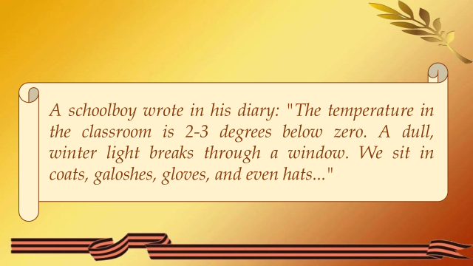
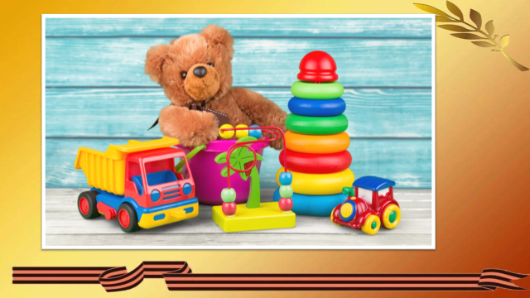 | 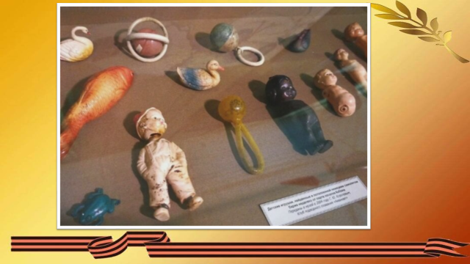
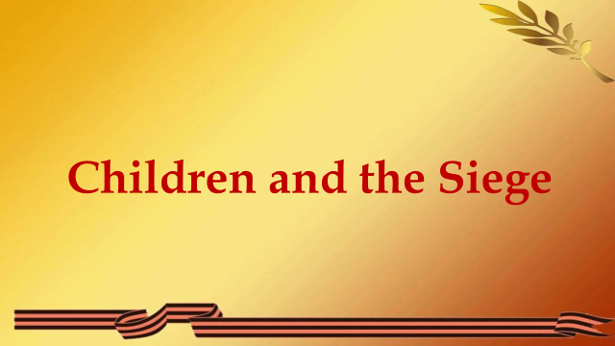 | 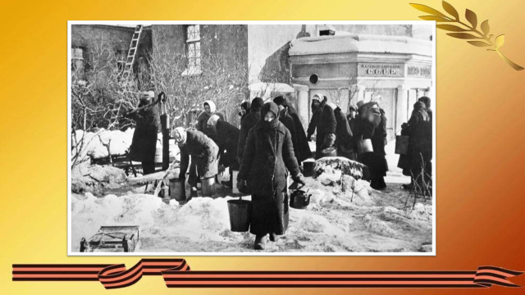
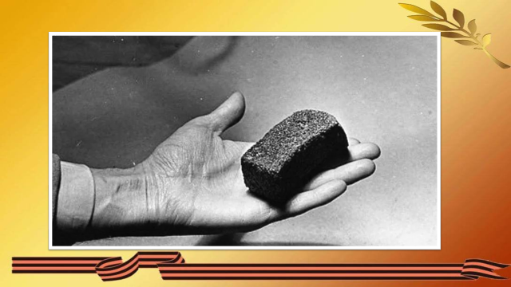 | 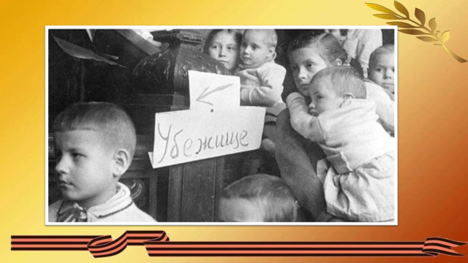
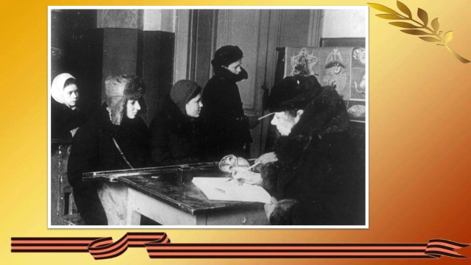 | 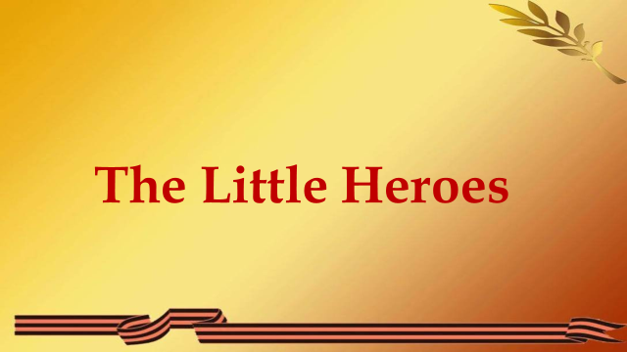
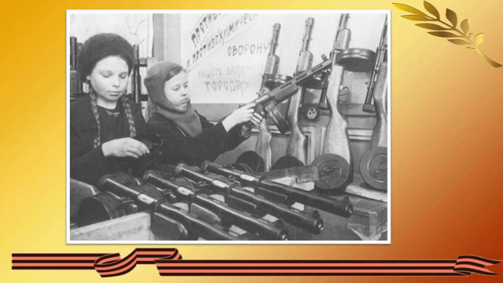 | 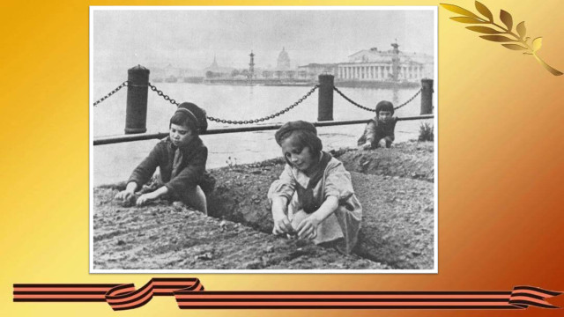
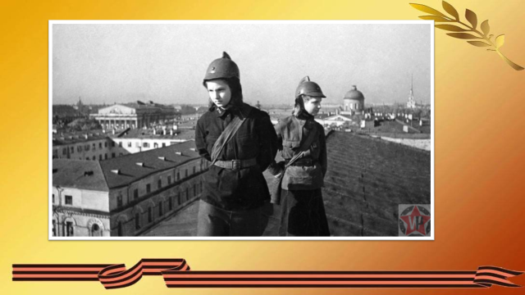 | 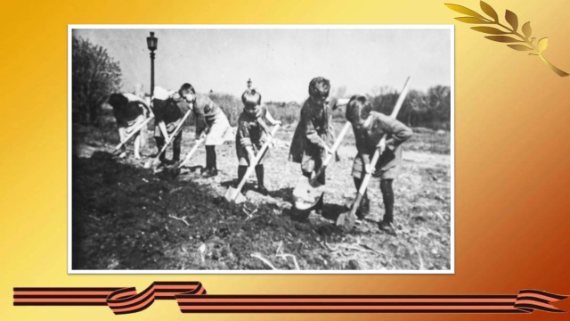
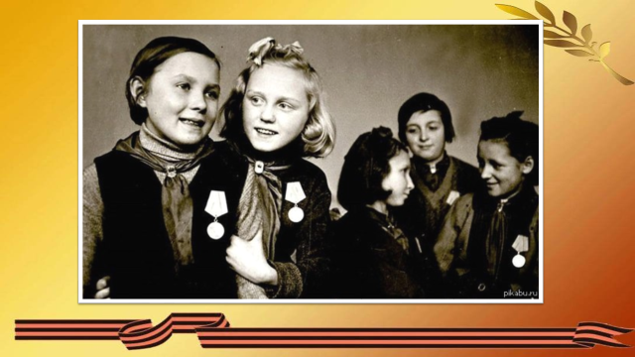 | 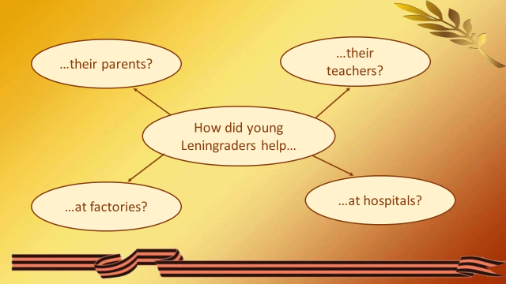
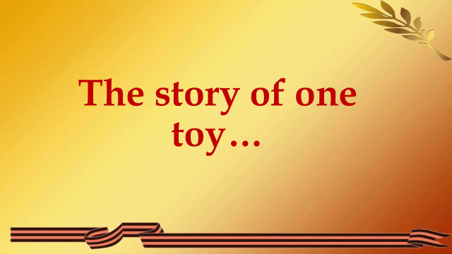 | 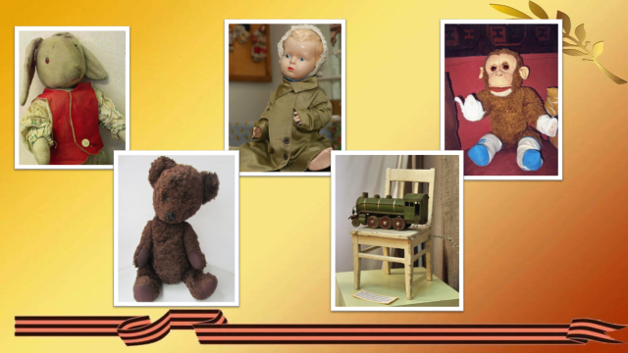
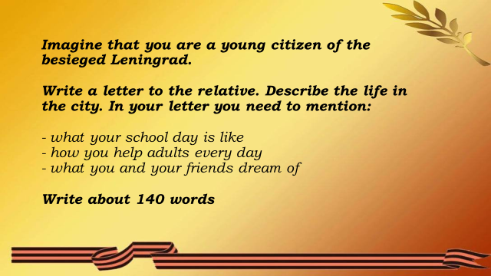 |   QR код к аудиофайлу Children and the Siege

